**Mini Project-1**

1. **Create a schema based on the given dataset**
2. create table agent_login(

sl_no int

agent_name string

day date

login_time string

logout_time string

duration string

)

row format delimited

fields terminated by ','

tblproperties ("skip.header.line.count" = "1");

1. create table agent_performance(

sl_no int

day date

agent_name string

total_chats int

average_response_time string

average_resolution_time string

average_rating float

total_feedback int

)

row format delimited

fields terminated by ','

tblproperties ("skip.header.line.count" = "1");

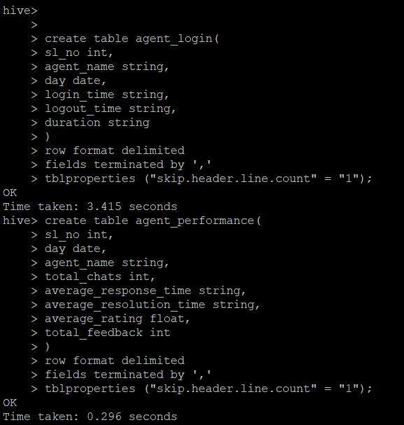

1. **Dump the data inside the hdfs in the given schema location.**

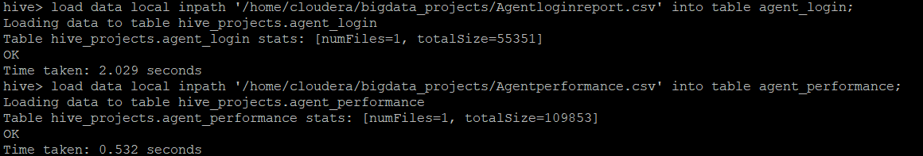

1. **List of all agents' names.**

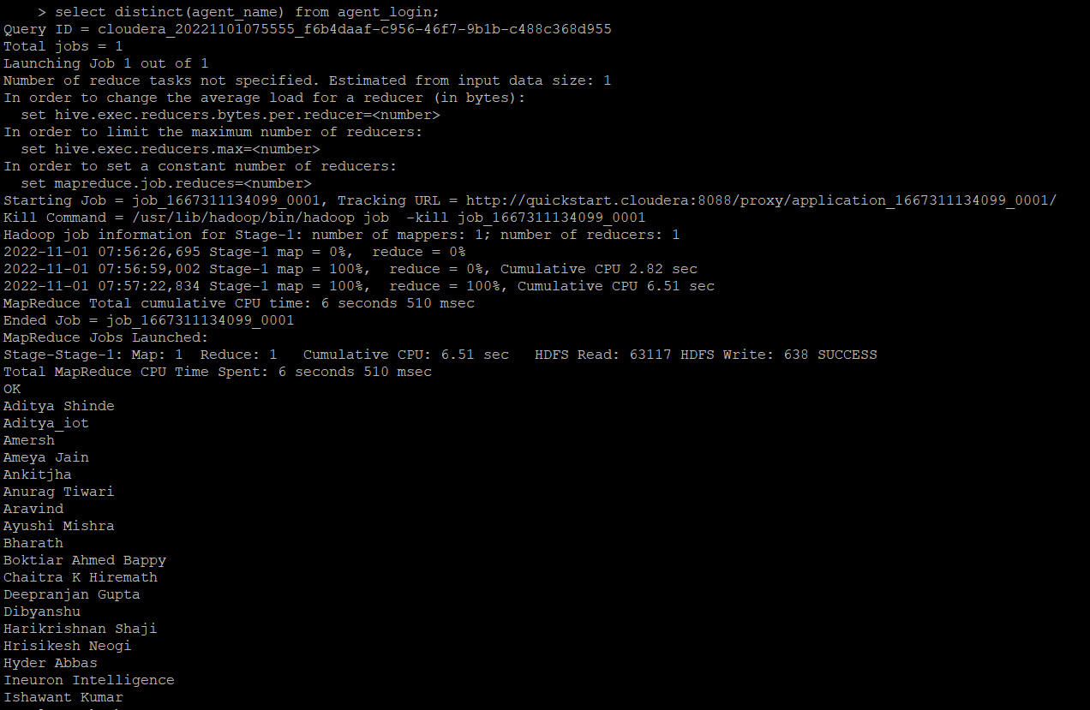

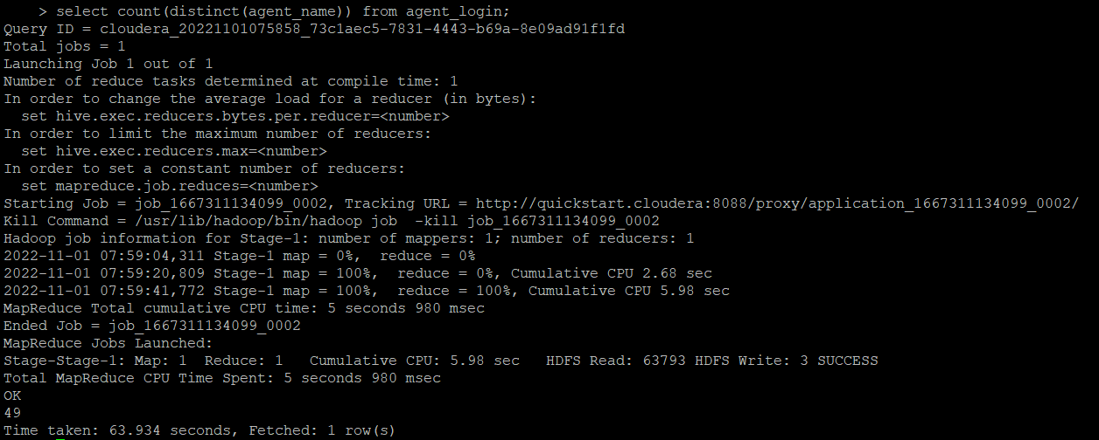

1. **Find out agent average rating.**

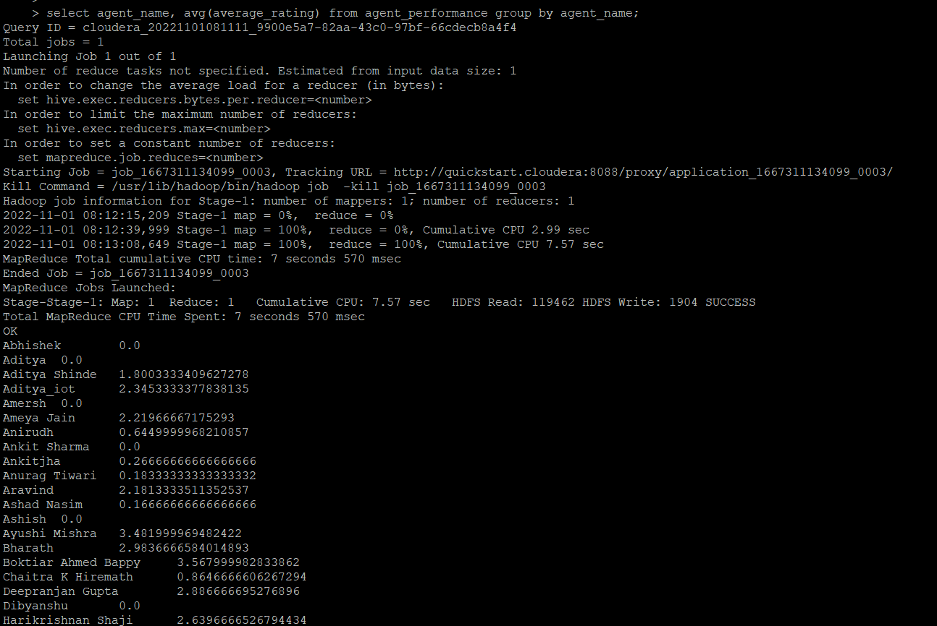

1. **Total working days for each agents**

select agent_name,count(distinct day) from agent_login group by agent_name;

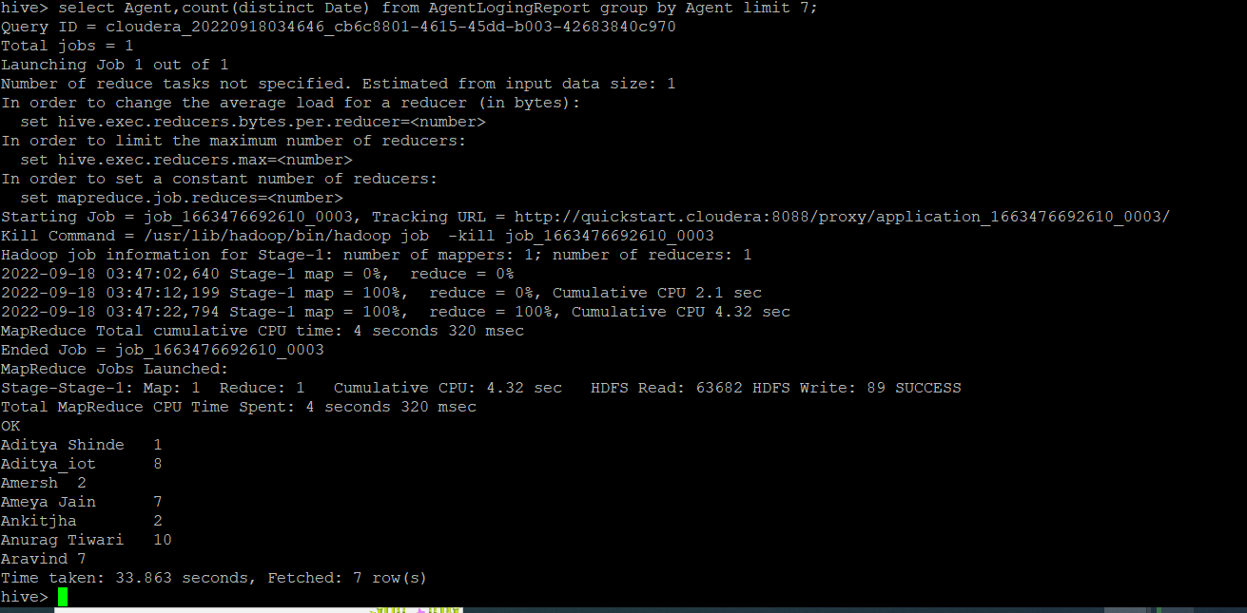

1. **Total query that each agent have taken**

select agent_name,sum(total_chats) from agent_performance group by agent_name;

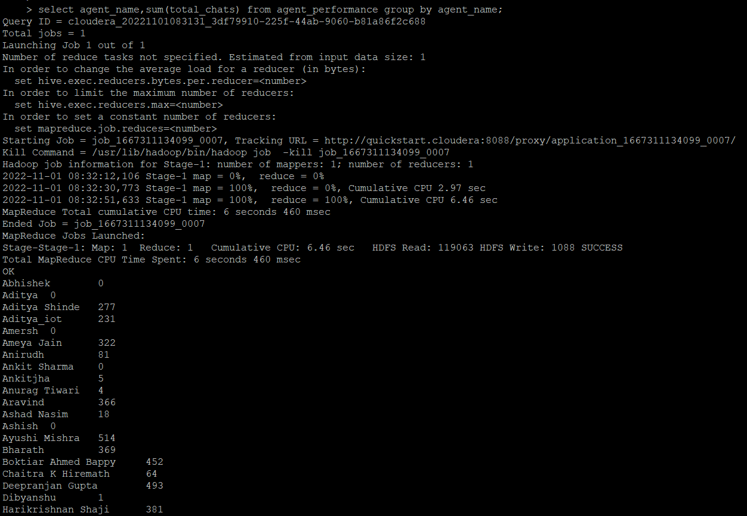

1. **Total Feedback that each agent have received**

select agent_name,sum(total_feedback) from agent_performance group by agent_name;

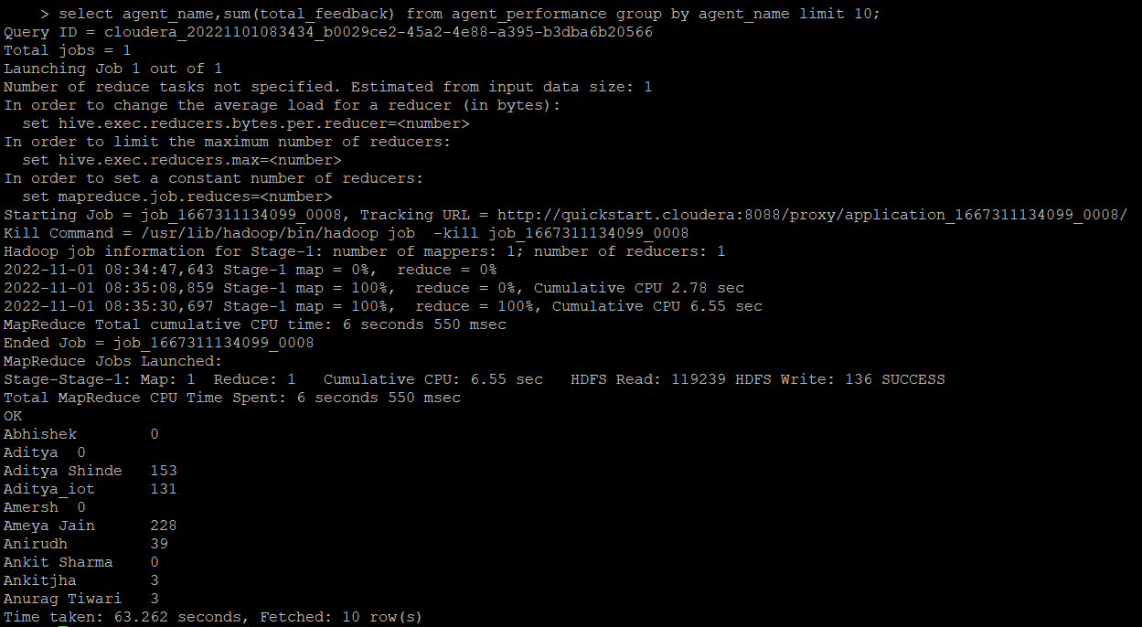

1. **Agent name who have average rating between 3.5 to 4**

select agent_name,average_rating from agent_performance where average_rating between 3.5 and 4;

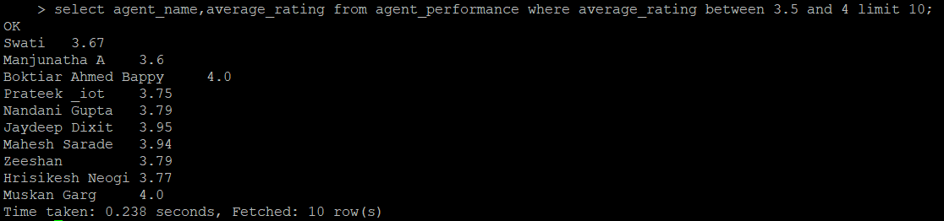

1. **Agent name who have rating less than 3.5**

select agent_name,average_rating from agent_performance where average_rating < 3.5;

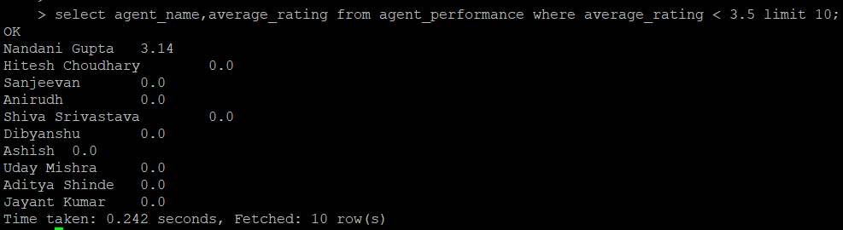

1. **Agent name who have rating more than 4.5**

select agent_name,average_rating from agent_performance where average_rating > 4.5;

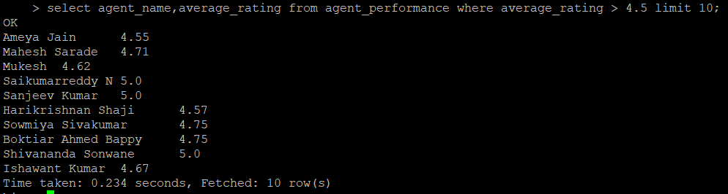

1. **How many feedback agents have received more than 4.5 average**

select agent_name, sum(total_feedback) from agent_performance group by agent_name having avg(total_feedback) > 4.5;

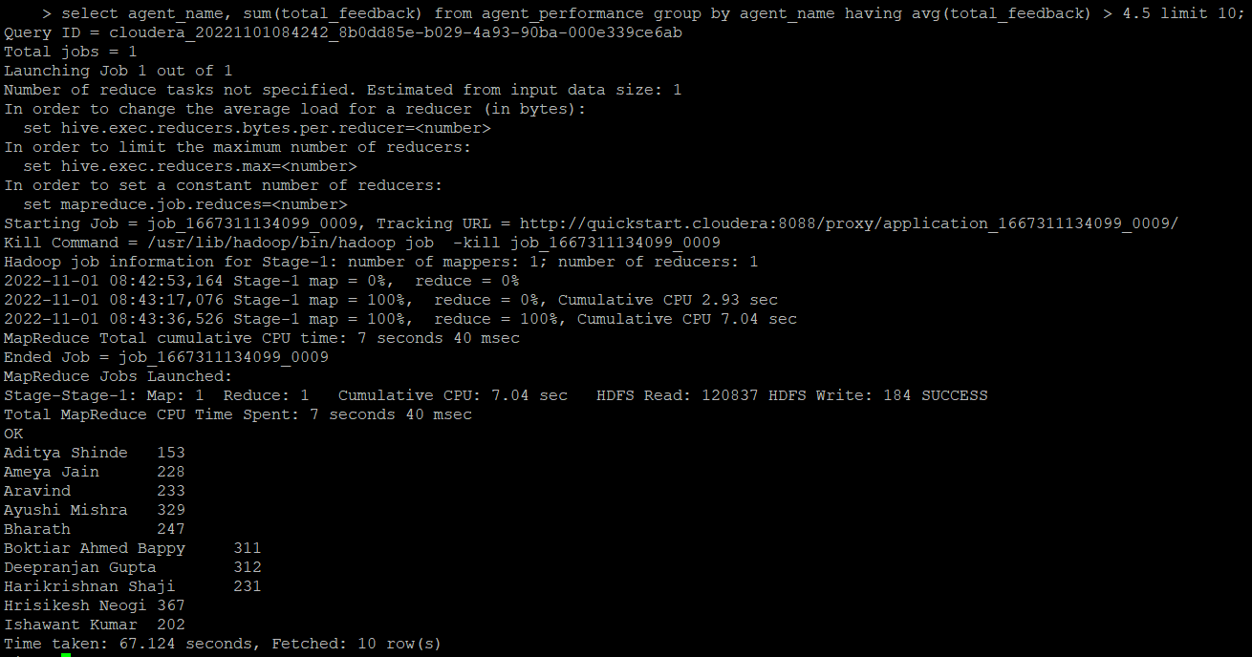

1. **average weekly response time for each agent**

select s.agent_name,avg(col1[0]*3600+col1[1]*60+substr(col1[2],1,2))/3600 from(

select agent_name,split(average_response_time,':') as col1 from agent_performance )s group by s.agent_name;

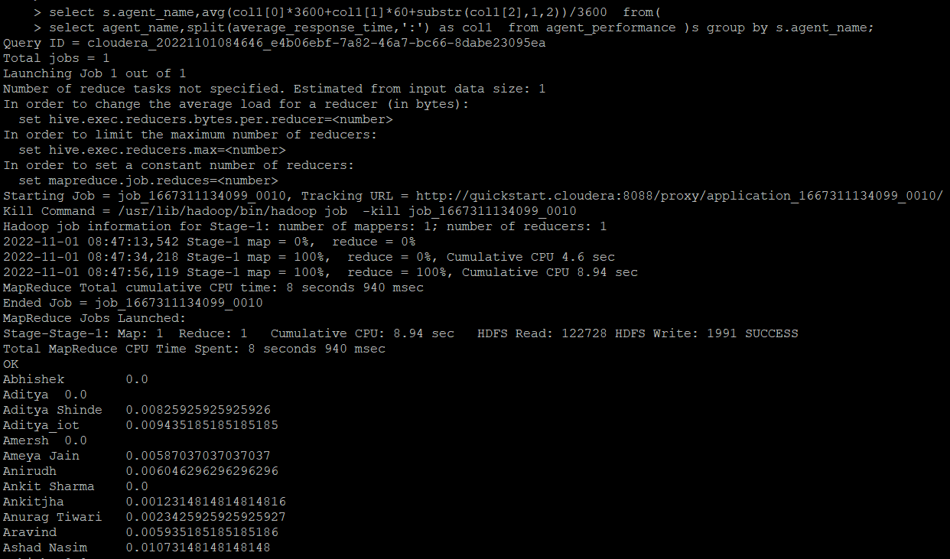

1. **average weekly resolution time for each agents**

select s.agent_name,avg(col1[0]*3600+col1[1]*60+substr(col1[2],1,2))/3600 from(

select agent_name,split(average_resolution_time,':') as col1 from agent_performance )s group by s.agent_name;

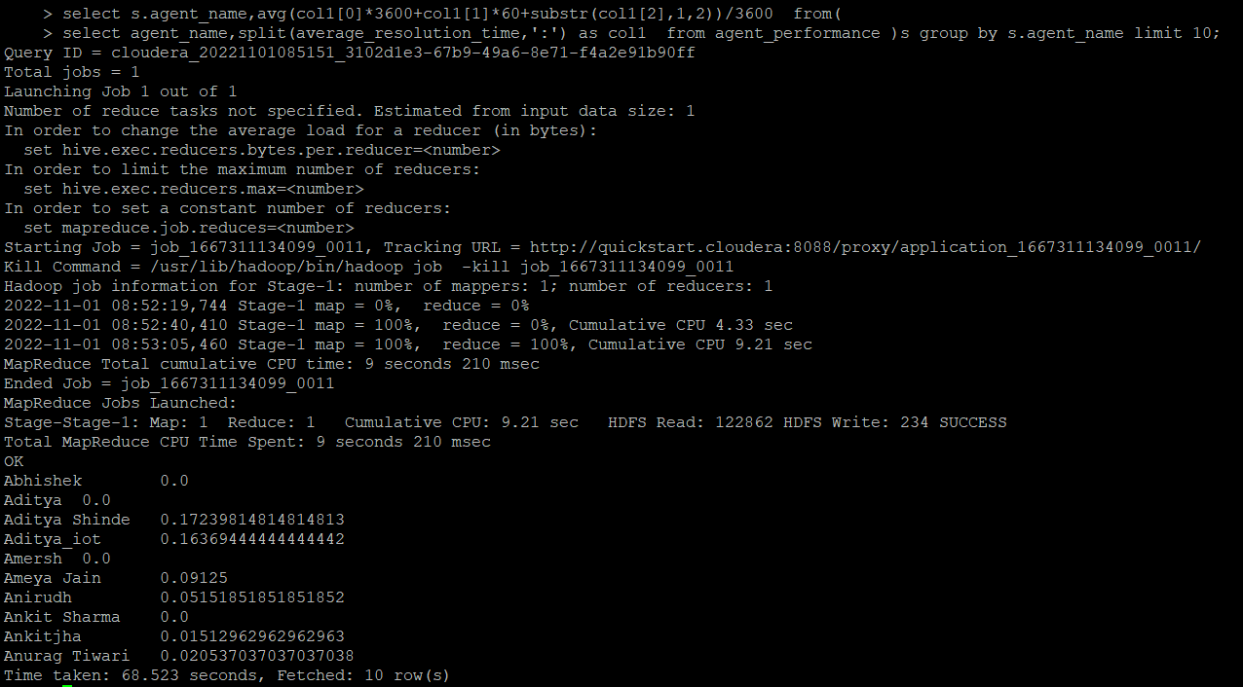

1. **Find the number of chat on which they have received a feedback**

select agent_name,sum(total_chats),total_feedback from agent_performance where total_feedback> 0 group by agent_name,total_feedback;

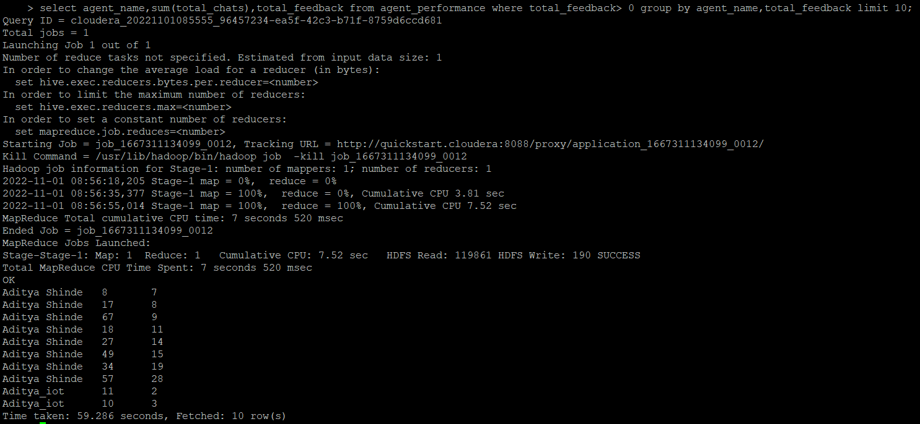

1. **Total contribution hour for each and every agents weekly basis**

select s.agent_name,sum(col1[0]*3600+col1[1]*60+col1[2])/3600 timeInHour,s.weekly from(

select agent_name,split(duration,':') as col1 ,weekofyear(day) as weekly from agent_login )s group by s.agent_name,s.weekly limit 2;

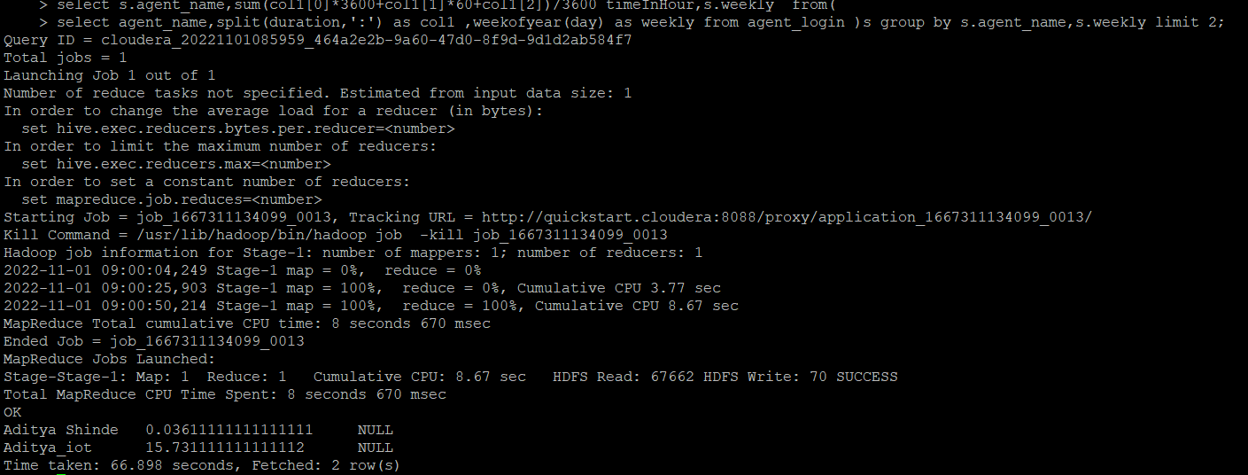

1. **Perform inner join, left join and right join based on the agent column and after joining the table export that data into your local system.**

hive -e 'select a.agent_name,a.day,a.duration,b.total_chats,b.total_feedback from challenge.agent_login a join challenge.agent_performance b on a.agent_name = b.agent_name' > /home/cloudera/bigdata_projects/inner_join.csv;

**left join:**

hive -e 'select a.agent_name,a.date,a.Duration,b.total_chats,b.total_feedback from challenge.agent_login a left join challenge.agent_performance b on a.agent_name = b.agent_name' > /home/cloudera/bigdata_projects/left_join.csv;

**left join with performance improved due to /*+ streamtable(a) */ hint:**

hive -e 'select /*+ streamtable(a) */a.agent_name,a.date,a.Duration,b.Total_charts,b.total_feedback from challenge.agent_login a left join challenge.agent_performance b on a.agent_name = b.agent_name' > /home/cloudera/bigdata_projects/left_join.csv;

**Right join:**

hive -e 'select a.agent_name,a.date,a.Duration,b.Total_charts,b.total_feedback from challenge.agent_login a right join challenge.agent_performance b on a.agent_name = b.agent_name' > /home/cloudera/bigdata_projects/right_join.csv;

**Right join with performance improved due to /*+ streamtable(a) */ hint:**

hive -e 'select /*+ streamtable(a) */a.agent_name,a.date,a.Duration,b.Total_charts,b.total_feedback from challenge.agent_login a right join challenge.agent_performance b on a.agent_name = b.agent_name' > /home/cloudera/bigdata_projects/left_join.csv; 17. Perform partitioning on top of the agent column and then on top of that perform bucketing for each partitioning.

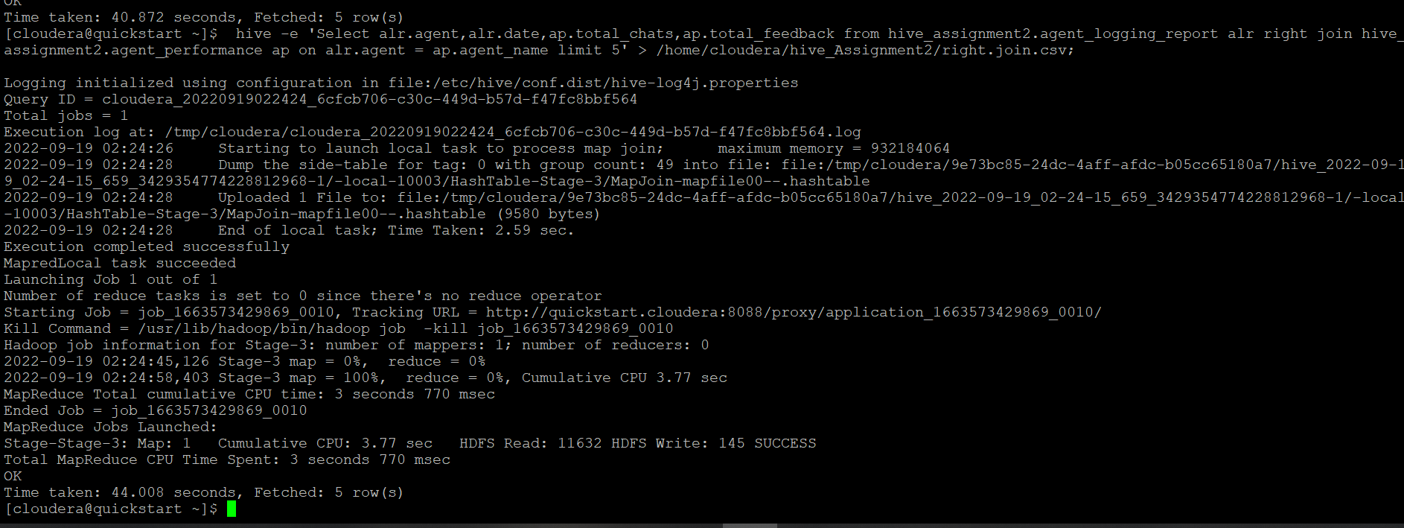

1. **Perform partitioning on top of the agent column and then on top of that perform bucketing for each partitioning.**

Create table ALR_partition_Bucket

(

sr_no int,

Date date,

Login_time string,

Logout_time string,

Duration string

)partitioned by (Agent string)

CLUSTERED BY (Date) sorted by (Date) INTO 4 BUCKETS

ROW FORMAT DELIMITED

FIELDS TERMINATED BY ',';

set hive.exec.dynamic.partition=true;

set hive.exec.dynamic.partition.mode=nonstrict;

hive> insert into table ALR_partition_Bucket partition(Agent) select sl_no,Date,Login_time,Logout_time,Duration,Agent from agent_logging_report;

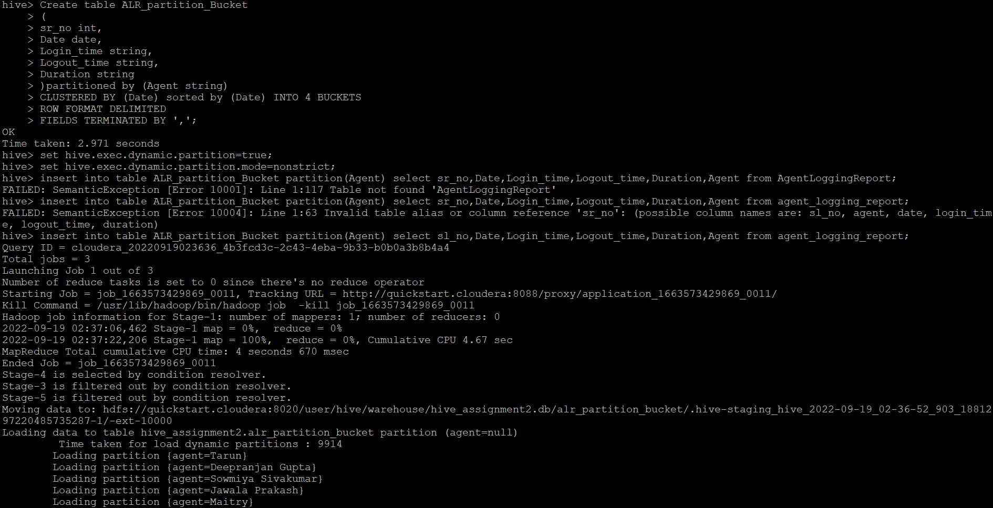

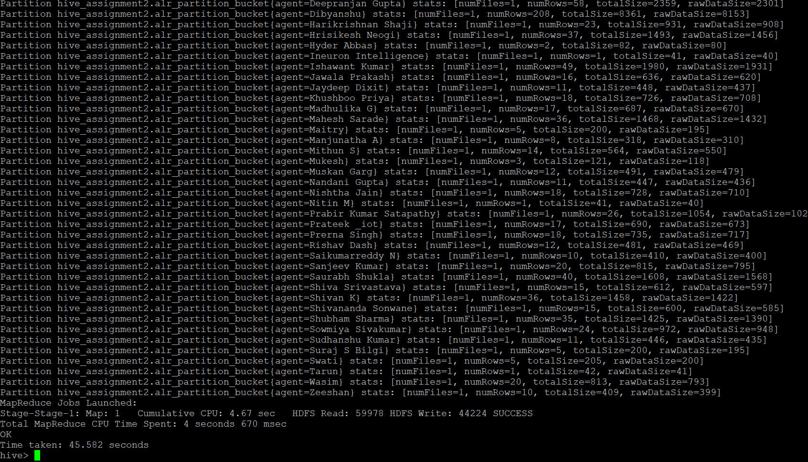

Create table AP_partition_Bucket

(

sr_no int,

Date date,

Total_chat string,

Average_Response_Time string,

Average_Resolution_Time string,

Average_Rating float,

Total_Feedback int

)partitioned by (agent_name string)

CLUSTERED BY (Date) sorted by (Date) INTO 8 BUCKETS

ROW FORMAT DELIMITED

FIELDS TERMINATED BY ',';

insert into table AP_partition_Bucket partition(agent_name) select sl_no,Date,Total_chats, Average_Response_Time, Average_Resolution,Average_Rating,Total_Feedback,Agent_name from Agent_performance;

